ANSIBLE
(Push Based Methodology)

Ansible works on push based methodology. Ansible is agentless such that it requires nothing to be installed on the target host machine except ssh connection and python.

Difference between chef and ansible
Chef →
- It works with client server architecture.
- It works with ruby.
- We need to register each and every host individually to the host machine.
- Chef is more secure than ansible.
- It is difficult to set up.

Ansible →
- It works with push based methodology. It works with python.
- It supports dynamic inventory.
- Ansible is not secure by default. We need to add an external module called vault.
- It is easy to set up.

RAW Module
It is also called a dirty module. If there is no python in the target machine we use raw module to install python or run it by some shell commands.

Ansible Inventory (/etc/ansible/hosts)
We have 2 types of inventory

→ Static Inventory
→ Dynamic Inventory
Static Inventory:
Static inventory is a file which contains the list of IP addresses of target host machines and groups them together based on user requirements in json or ini format. Default location of inventory is /etc/ansible/hosts

Dynamic Inventory :
Ansible team will provide two file, python script and ini file. When we execute script it will automatically fetch the address of target host machines and stores it in the inventory file. Only thing we have to update is the path of inventory file in python script.

Modules:
- Ping Module : It is used to check connection of target host machines. It will get reply with pong.
Syntax → ansible ip_address(target m/c) -m ping ansible group_name -m ping
ansible -i inventory_filename -m ping
- Packaging Module : It is used to install packages. It is same as yum in centos/rhel and apt in ubuntu/debian.
- copy madule ---> it is used to copy a file from host machine to the multiple target machines.
Syntax:
copy:
src: source path
dest: destination path

- how to change the permission of a file?
sol. Using file module
syntax:
file:
path: file path
mode: 0744
owner:
group:

S tate Module (hydo-potential behaviour):
state: present → It will check for the package is already installed or not. If not
installed then only it will install the package.
state: latest → It will check whether the package is installed or not, if it is installed it will ensure up to date or install with the latest version.
state: removed → It will uninstall the package.
state: absent → It will uninstall the package.

Become Module :
Privilege Access : If i want to run with root permissions or other user privilege permission. For this we will use the become module
Syntax → become: yes
become_user: user_name
- update_cache: used to update repository
update_cache: yes
- template: It is used to copy dynamic files from host machine to target hostmachine. Make sure that file has to be created in jinja format (.j2).
template:
src: source path
dest: destination path

Ansible Ad hoc Commands:
An Ansible ad hoc command uses the /usr/bin/ansible command-line tool to automate a single task on one or more managed nodes. ad hoc commands are great for tasks you repeat rarely. Ad hoc tasks can be used to reboot servers, copy files, manage packages and users, create directory, to check the connection of target host machines etc.
Syntax:
Ansible hostname -m module_name -a module_options
The -a option accepts options either through the key=value syntax or a JSON string starting with { and ending with }
Ex:
- To Check the connection of Target Host machine
ansible all -m ping
ansible group_name -m ping
ansible host_ipaddress -m ping
- To Reboot server
ansible all -m “/sbin/reboot”
- To execute shell commands
ansible all -m shell -a “wc -c /home/ubuntu/1.txt” to count no of characters in 1.txt file which is in target host machine
ansible all -m shell -a “touch /home/ubuntu/1.txt” create a file in target host machine
- To copy a file from host machine to target host machine
ansible all -m copy -a “src=/home/ubuntu/1.txt dest=/home/ubuntu/”
- To create a directory
ansible all -m file -a “dest=/home/ubuntu/new mode=777 owner=root group=root state=directory”
- To delete whole directory and files
ansible all -m file -a “dest=/home/ubuntu/new state=absent”
- To manage packages
ansible all -m yum -a “name=git state=present” to install
ansible all -m yum -a “name=git state=absent”

Ansible Playbook:
Playbooks are the files where Ansible code is written. Playbooks are written in YAML format. YAML stands for Yet Another Markup Language
Ex: Refer class notes for scripts
To execute playbooks use ansible-playbook filename and to execute in debug mode ansible-playbook filename -vvv

Ansible-vault: (how you are going to secure ansible)
Sol: using ansible-vault
Ansible vault is a feature of ansible that allows you to keep sensitive data such as password or keys in encrypted files, rather than plaintext in playbooks or roles.
Commands:
- Create: it is used to create ansible vault file in the encrypted format.
ansible-vault create 1.yml
- View: To view the data of encrypted files.
ansible-vault view 1.yml
- Edit: It is used to edit the encrypted file
ansible-vault view 1.yml
- Encrypt: used to encrypt the unencrypted files
ansible-vault encrypt 1.yml
- Decrypt: used to decrypt an encrypted files
ansible-vault decrypt 1.yml
- --ask-vault-pass: used to provide passwords while running playbooks
Ansible-playbooks 1.yml –ask-vault-pass
- --vault-password-file: used to pass a vault password through a file

Refer:
- https://www.youtube.com/watch?v=L8GzW4sopug
- https://www.youtube.com/watch?v=XNr3BbCtSmA

Ansible-galaxy: it is a command used to create and managing the roles.ansible galaxy is large public repository of ansible roles.
ansible-galaxy list : it dispaly a list of installed roles with version number
ansible-galaxy remove role_name : it will remove an installed role
ansible-galaxy info : it will provide a information about ansible-galaxy
ansible-galaxy init Role_name : to create a role

Roles: Roles splits the single playbook into multiple files. Ansible roles is defined with 8 directory and with 8 files, roles must include at least contain one of above directories.

Directory structure of roles:
sample
├── defaults
│ └── main.yml
├── files
├── handlers
│ └── main.yml
├── meta
│ └── main.yml
├── README.md
├── tasks
│ └── main.yml
├── templates
├── tests
│ ├── inventory
│ └── test.yml
└── vars
└── main.yml

default: default variable for the roles
files: conain files which can be deployed through roles
handlers: which contains handlers which may be used by this role or even anywhere outside this role
meta: Define some meta data for this role
tasks: contain the main list of tasks to be executed by the roles
templates: it contains templates(files) which can be deployed through this roles
tests: it may contain simple inventory and a test,it may be usefull if u on automated testing process which is build through roles
vars: variables used in the role

Difference B/w default and vars
Default have lowest priority value than any other variables in ansible. Vars will have the highest priority than default

Difference B/w files and templates:
Ansible files are used to copy static files without changing any contents from host machine to target machine.
Templates take the files from hosts machine and changes the contents of files (value of variable defined in templates) before copying. It can be done using jinja filter (.j2 format) and then it will copy a file to the target machine.

Handlers: Handlers are the special type of tasks which is executed only when there is change in state need to be defined under handlers.
Handlers are called using notify and execute once all tasks in playbook are executed.
Multiple tasks can notify the same handler.
Note: In output u can observe changed=1 then only handler will execute
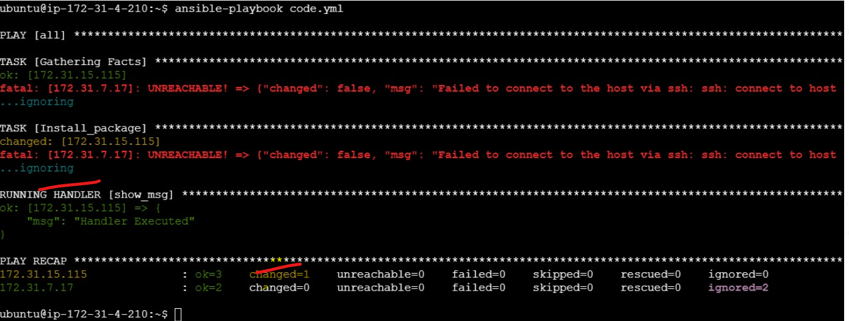
Fig: Handler will be executed, since changed=1
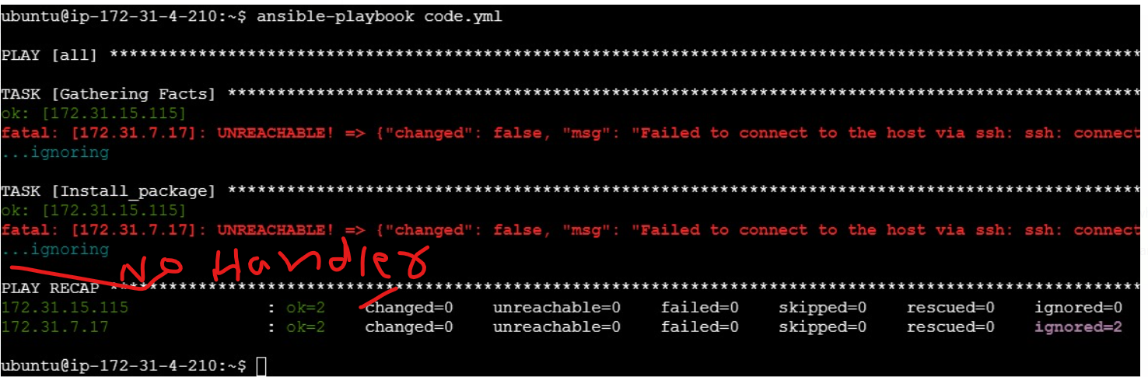
Fig: No handler executed when changed=0
How will you call handlers?
Using notify
Syntax: - notify: handlers name

How will you include yml (playbooks) file within another yml (playbooks) file or how will you call yml files from another yml file.
Using include
Syntax: - include: yml_file_name

Error handling:
By default Ansible stops executing tasks on a host when a task fails on that host.
ignore_errors:
You can use ignore_errors to continue on in spite of the failure.
ignore_errors: true

Ignoring unreachable host errors:
You can ignore a task failure due to the host instance being ‘UNREACHABLE’ with the ignore_unreachable keyword. Ansible ignores the task errors, but continues to execute future tasks against the unreachable host. For example, at the task level:
ignore_unreachable: true

Handlers and Failures:
Ansible runs handlers at the end of each playbook. If a task notifies a handler but another task fails later in the playbook, by default the handler does not run on that host, which may leave the host in an unexpected state. For example, a task could update a configuration file and notify a handler to restart some service. If a task later in the same playbook fails, the configuration file might be changed but the service will not be restarted.
You can change this behavior with the force_handlers: true in a playbook. When handlers are forced, Ansible will run all notified handlers on all hosts, even hosts with failed tasks.

Defining faiures:
Ansible lets you define what “failure” means in each task using the failed_when conditional. If you want to trigger a failure when any of the conditions is met, you must define the conditions in a string with an explicit or operator.

Defining changed:
Ansible lets you define when a particular task has “changed” a remote node using the changed_when conditional. This lets you determine, based on return codes or output, whether a change should be reported in Ansible statistics and whether a handler should be triggered or not.
Ansible facts:
Ansible collects pretty much all the information about the remote hosts as it runs a playbook. The task of collecting this remote system information is called as gathering facts by ansible and the details collected are generally known as facts or variables. This information can be obtained manually using ansible adhoc command and a specialized module named setup.
ansible all -m setup
These ansible facts would be collected for each hosts in your hostgroup before playbook execution until you disable it explicitly by defining gather_facts: no

Ansible Tower: It is a web-based user interface and dashboard developed by Red Hat for managing Ansible projects. It extends the functionality of Ansible by providing enterprise features such as role-based access control, scheduling, and centralized logging. Ansible Tower is particularly useful for teams and organizations that require advanced automation capabilities and collaboration. Ansible Tower can be used for Application Deployment, Configuration Management, Role-Based Access Control and Cannot be used in CI/CD Pipelines, Event-Driven Automation, Real Time Monitoring

Official Support: Ansible Tower is officially supported on Red Hat Enterprise Linux (RHEL) and CentOS. In ubuntu we can use it by creating a docker container.

Ansible Collections: Ansible Collections are the packages of reusable automation content (roles, modules, playbooks, etc.) that can be shared and managed via Ansible Galaxy or private repositories, promoting modularity, extensibility, and code reuse.
1. Official Collection
Definition: Official collections provided and maintained by Ansible (Red Hat). These collections cover a wide range of use cases and systems.
Ex: ansible.posix (for managing POSIX-compliant systems like Linux).
2. Community Collection
Definition: Collections created and maintained by the Ansible community. These collections often cover broader or niche tasks.
Ex: community.general (a general-purpose collection with modules for a variety of systems and use cases).
ansible-doc -l | grep community.general
3. Custom Collection
Definition: Collections developed internally by an organization for its specific use cases and requirements. These may not be publicly available.
Ex: myorg.web (a custom collection for managing web applications within the organization).
4. Cloud Provider Collection
Definition: Collections tailored for managing cloud resources (e.g., AWS, Azure, Google Cloud, etc.).
Ex: amazon.aws (for managing AWS resources like EC2 instances, S3 buckets, etc.).
ansible-doc -l | grep amazon.aws
5. Platform-Specific Collection
Definition: Collections focused on managing specific platforms or operating systems.
Ex: ansible.windows (for managing Windows-based systems).

Commands:
ansible-galaxy collection list
ansible-doc -l | grep ansible.posix
ansible-doc -l | grep community.general

